Functional Description: Segment Wagon

System Overview
  - The segment wagon is used to take 1 segment from the launch shaft, into the tunnel and to the erector to unload. There are rails built modularly on the tunnel invert for the segment wagon to run on. This along with the T09 umbilical gantry will be used until the shield reaches 165m, where the backup gantries are then installed for the remaining drive. The segment wagon will carry approximately 570 segments and 95 rail modules to the erector in its lifespan. The travel distance will increase from 0 - ~ 160 m. The system is limited in height and width by the T09 gantry.

Rail Movement
- The segment wagon is driven by 4 DRS-M Demag wheels and braked gearmotors (1.1kw each). All 4 wheels are driven and controlled simultaneously using a radio remote control with operator walking on the tunnel walkway. Pendant control is also required as a backup. Full speed will be 32m/min. Controls should be able to achieve slower speeds once nearing the T09 and erector/end of travel. The control speeds should be achieved in both forward and reverse. An encoder will be zeroed at the entrance of the tunnel & the HMI will have a function to increase the distance to end of travel. There will be a ramp down point to slow speed 2 meters before stop position (either end of rail). Full speed not available until the wagon is reversed back past the ramp down point. A limit switch will be mounted as a backup method to ensure the wagon will stop & not drive through to mechanical stops. Mechanical stops on the rail ends will be used. Power comes from an onboard generator 18 kVA Genelite.

Segment Rotator
- The segment wagon is fitted with a 0.55kw electric motor rotator allowing the segment to be rotated 90° once it is in front of the T09 gantry before moving under the erector. The system will have an encoder that will be zeroed at forward facing direction, with the capability of rotating 180 & -180 degrees from home position. Longitudinal travel speed must be limited until the encoder is at the zero position (concrete segment sitting straight to avoid clashing with surrounding objects). When out of 0° or 180° rotation the wagon speed will be limited to ~10m/min.

Key Components
    - 4 x Demag wheel blocks with 4 x Demag braked gearmotors ~1.1kw (AME 20 DD-M0-35-1-18.1 ZBP 90 B 4 B020)
    - 1 x 18 kVA diesel generator
    - 1-2 switchboards available window beside generator. Could be 2 x 800w x 1000h x 400d if 200mm is enough for cable exit to floor height. This allows vertical hinged doors.
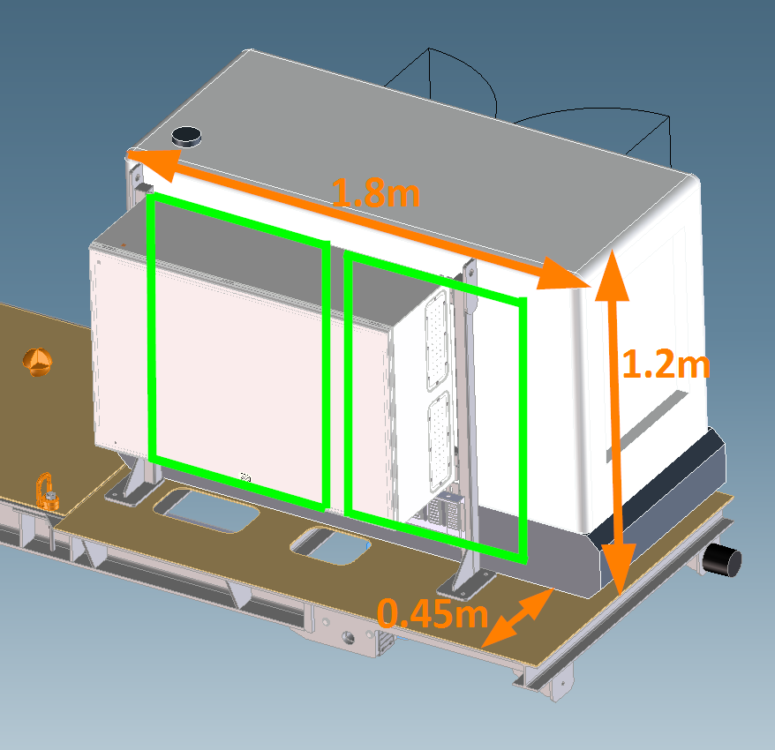
    - 1 x radio remote control for operation of the segment wagon (fwd, rev, rotate, horn, reset remote start generator)
    - 1 x backup pendant control, plug in for operation (fwd, rev, rotate, horn, reset remote start generator) (~4m tail for operator to walk behind)
    - 1 x rotator electric
    - 1 x e-stop on rear and 1x maintenance switch on switchboard etc.
    - Onboard flashing light and audible alarm
    - Onboard carriage encoder
    - Onboard rotator encoder
    - 1 X Limit switch for end of longitudinal travel stop

Concept Model
